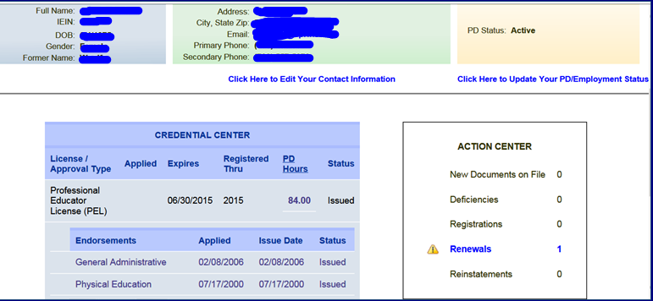

**This is an Active Link IF you have entered ALL of your necessary PD,** it will be listed on your homepage. If you have NOT entered your PD go do so and there will be a link at the bottom of your PD page. Or you can go back to homepage for access.

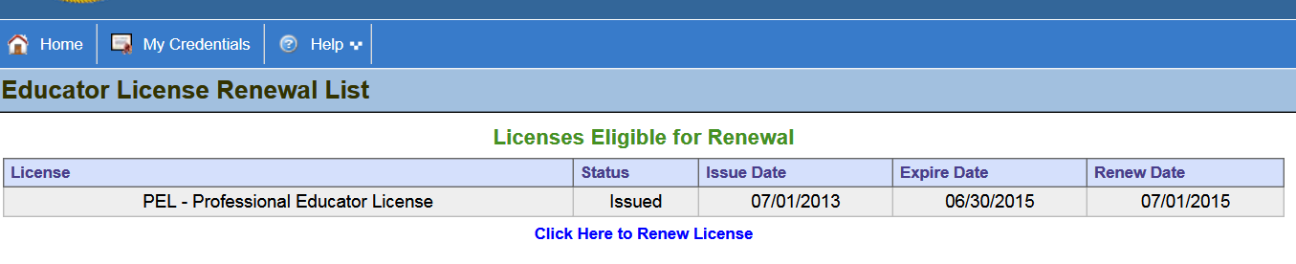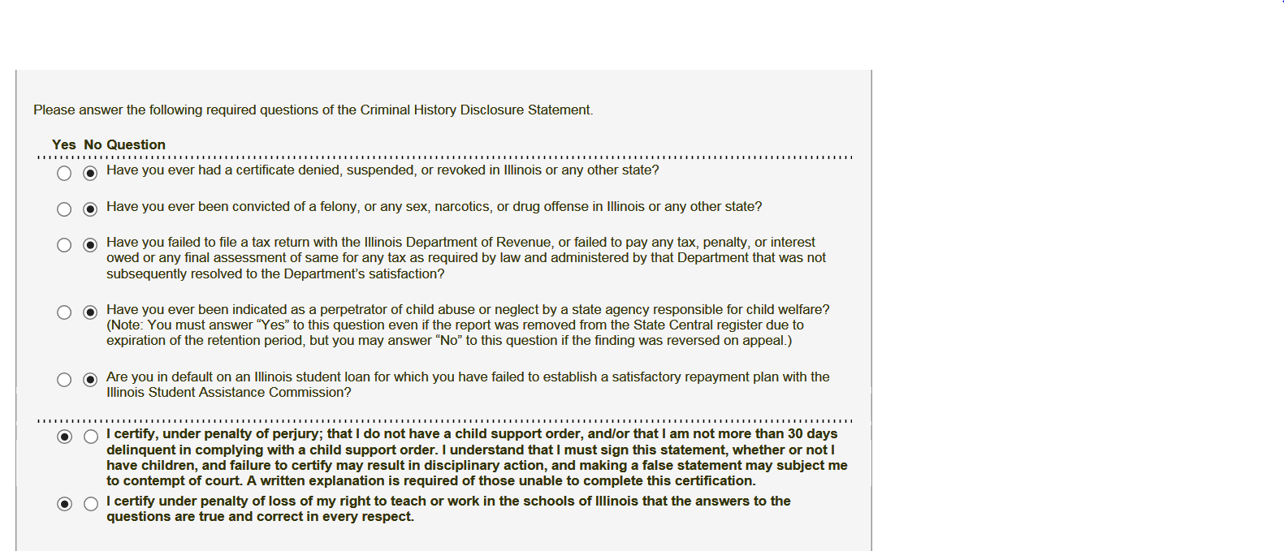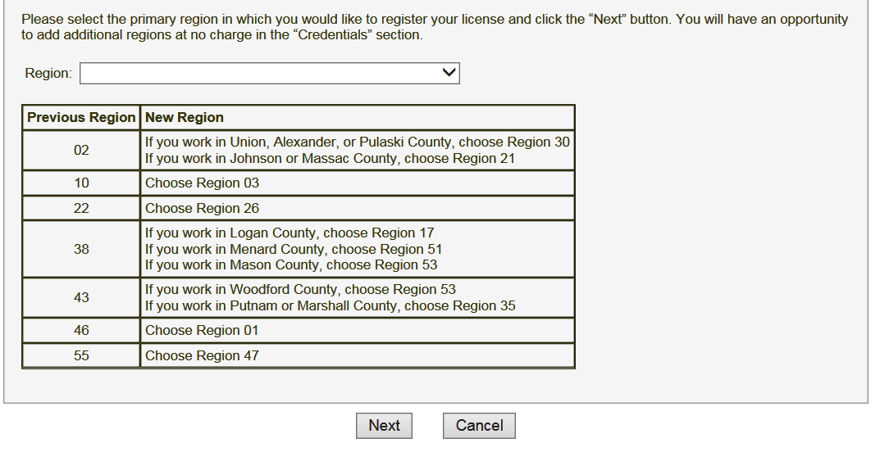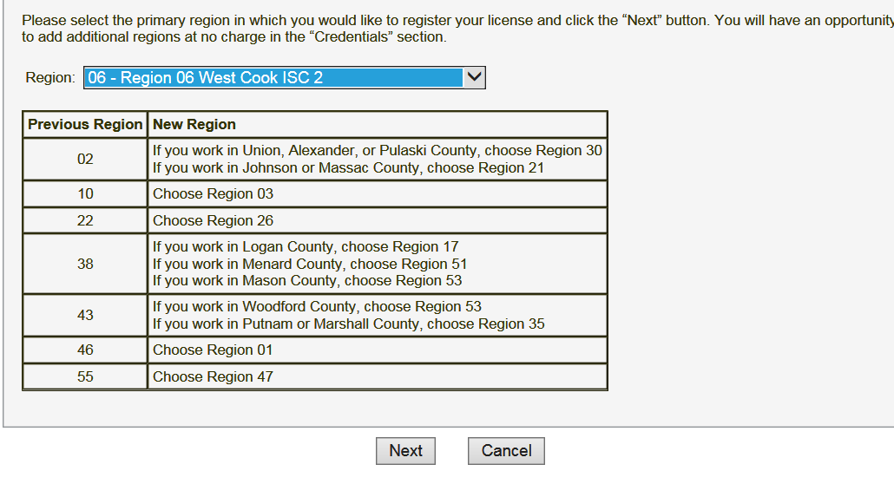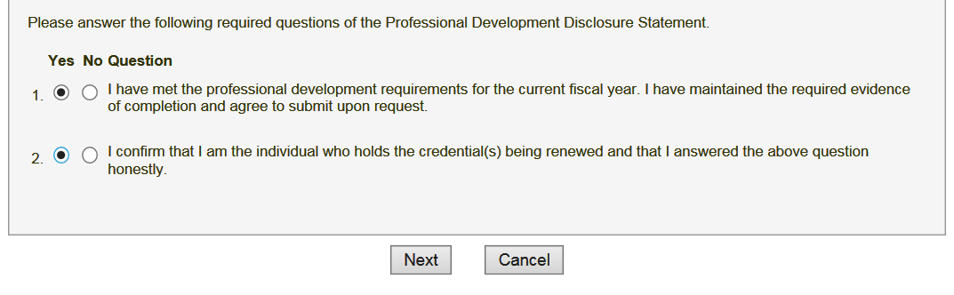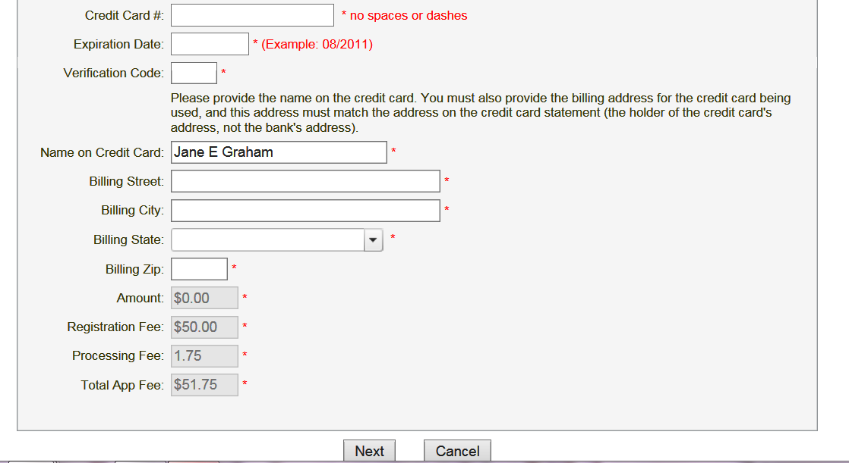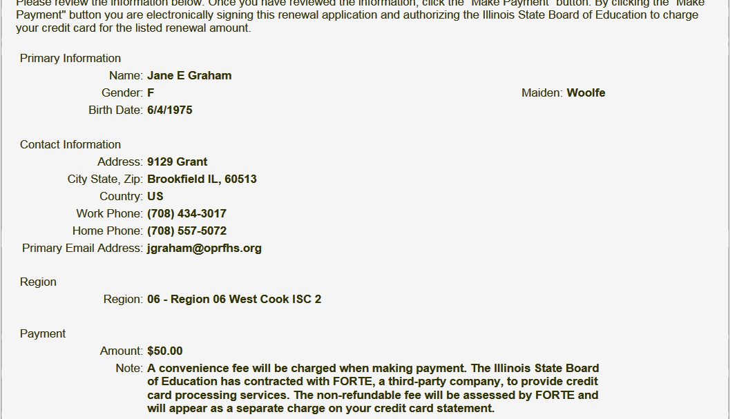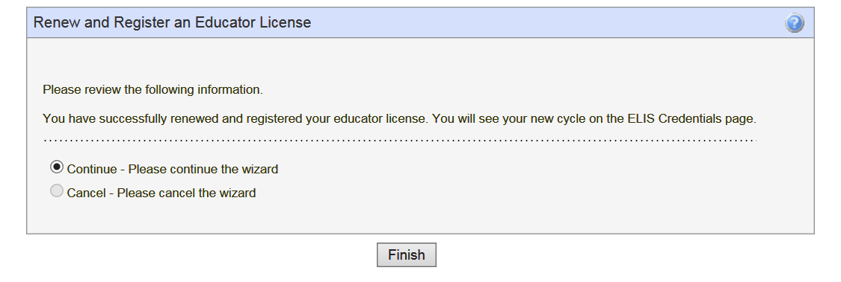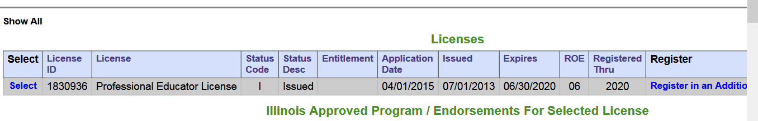

Answer Questions. You should look like this unless there is a problem.

My OPRF Friends we are in Region 6 this is in the drop down menu. See next box.

Keep clicking Next there are a bunch of questions in the renewal wizard.

Have your credit card ready. It is ONLY $51.75 for 5 YEARS!!

Do a double check. You should see that you are now expiring on 06/30/2020. This happens immediately after submission! Now you are set for 5 years. You need 120 PD hours from here on out and you have to enter them within 60 days of completion!